**Biology: 16. Plant Reproduction**

***Please remember to photocopy 4 pages onto one sheet by going A3→A4 and using back to back on the photocopier***

**Syllabus**

**OB51** Distinguish between asexual and sexual reproduction in plants and describe a way in which a named plant can reproduce asexually

**OB52** Locate and identify the main parts of the flower: sepals, petals, carpel and stamen

**OB53** Use a suitable flower to identify the stigma, style, ovary, anther and filament

**OB54** Understand that the stamen (anther) produces pollen, the carpel (ovary) produces the egg cell, the pollen produces the male gamete for fertilisation, the ovary produces the female gamete for fertilisation, and pollen is transferred by wind and by insects

**OB55** Recall that seed formation follows fertilisation, and describe seed dispersal

**OB56** Describe seed structure (testa, food supply, radical, plumule)

**OB57** Understand that seed germination is necessary to produce a new plant

**OB58** Investigate the conditions necessary for germination

**Questions to make you think**

1. Did coloured plants exist before insects evolved? Why/ why not?
2. Why is oxygen needed for germination – I thought plants took in carbon dioxide?

**Student Notes**

**Labelled diagram of a flower**

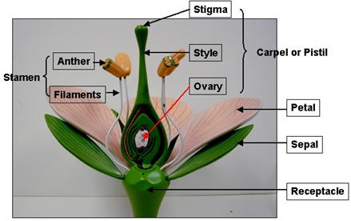

**The Petal**

Petals are used to attract insects into the flower; they may have guidelines on them and be scented.

**The Sepal**

The flower is protected while it is in bud by the sepals, these may be coloured green or have the colour of the petals.

They are often brightly coloured to attract the insects.

**The Stamen**

**The stamen produces the male gamete (male sex cell) for fertilisation.**

**The male sex cell is called sperm**

Inside the petals are the stamens, these are the male part of the flower. Each stamen consists of an anther and a filament. The anther produces pollen (which contains the sperm); the filament raises the anther up in the flower.

This enables the visiting insects to rub against it and so pick up the flowers pollen.

**The Carpel**

**The carpel produces the female gamete (female sex cell) for fertilisation.**

**The female sex cell is called an egg**

In the centre of the flower is the female part, the carpel(s). Each carpel consists of stigma, style and ovary.

**The Life Cycle of the Flowering Plant**

The life cycle of the flowering plant consists of 5 stages ( think “**P**retty **F**lowers **F**or **D**reamy **G**irls”):

(a) **P**ollination (b) **F**ertilisation (c) **F**ruit & Seed Development (d) **D**ispersal (e) **G**ermination.

These stages form a continuous cycle: a → b → c → d → a etc.

**(a) Pollination**

**Pollination is the transfer of pollen grains from an anther (male part) to a stigma (female part).**

Pollination can be enabled by:

(1) **Insects** who visit the flower in order to obtain pollen or nectar as food: the insects rub against the sticky stigma and so the pollen (which was gathered from the stamen of one plant) can end up on the carpel of another plant.

(2) **Wind** which blows the pollen from one flower to another (and makes you go ‘ahh-chooo!).

(3) **Self-pollination** occurs when the male and female parts of the flower are ripe at the same time and when the pollen can fall onto the sticky stigma.

**(b) Fertilisation**

**Fertilisation is the union of a nucleus of the pollen grain with the nucleus of the egg.**

When the pollen grain lands on the carpel it develops a pollen tube which grows down from the stigma, through the style and into the ovary where fertilisation takes place.

Here the nucleus (the male gamete) joins with the nucleus of the egg (the female gamete).

**(c) Fruit & Seed Development**

After fertilisation the egg develops into a seed. The parent plant provides the food for the growth.

The seed is provided with energy and raw materials to enable it to become established after dispersal, provided the environment is suitable.

**Structure of a seed**

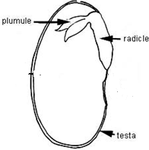**Testa**: the tough outer covering.

**Radical**: the part growing down out of the seed

(grows to form the root; think ‘R’ for Radical, ‘R’ for Root).

**Plumule**: the part growing up (this grows to form the shoot).

**Food supply**: The inside of the seed consists of stores of food.

**(d) Dispersal (of Fruit & Seed)**

If the seeds didn’t get dispersed then they would all simply fall to the ground and there wouldn’t be enough food, light or water for all to develop. So they need to get away from the parent plant.

There are many ways in which seed can get transferred from one plant to another

|  |  |  |  |
| --- | --- | --- | --- |
| **Dispersal** | **Wind** | **Insect** | **Self** |
| Example: | Dandelion | Strawberry | Peas (they ‘explode’ or pop) |

**(e) Germination**

**Germination is the resumption of growth after a period of dormancy.**

The food reserves in the seed are used to allow the root to grow down and the shoot to grow up.

The roots then absorb water and minerals and the leaves carry out photosynthesis.

**Moisture, oxygen and heat are necessary for germination**

**To investigate the conditions necessary for germination**



Procedure:

1. Place cress seeds in cotton wool in each test-tube.
2. Add moist cotton wool to one
3. Add water which has cooled after boiling to another and cover it with oil (this means there will be no oxygen).
4. Add dry cotton one to another (no water).
5. Keep another in the fridge (no heat).

Result: Only the test tube containing the moist cotton wool at room temperature germinated.

Conclusion: Moisture, oxygen and heat are necessary for germination

**A nice variation**

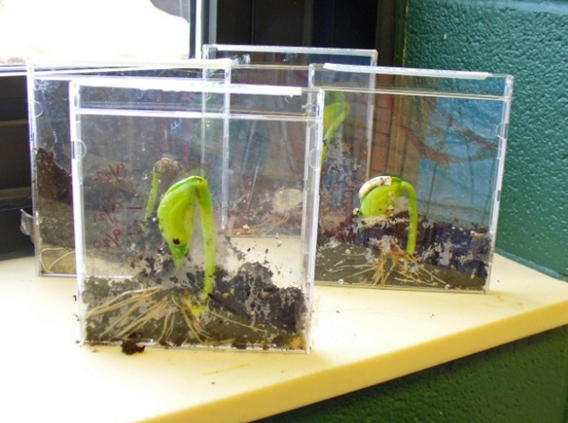

**Asexual reproduction**

The exception to the normal sexual reproduction in plants is known as asexual reproduction

**Asexual reproduction involves the formation of new individuals from the cell(s) of a single parent.**

Examples of plants that reproduce asexually include grass, strawberries, daffodils, onions and potatoes.

All plant organs have been used for asexual reproduction, but stems are the most common.

**The Interesting Bits**

**More on asexual reproduction**

Asexual reproduction in flowering plants is common.

Many different seed plants utilize one of a number of different methods of this form of reproduction.

There are several reasons why seed plants may find this form of reproduction advantageous.  If the environment has been stable for many generations, variability may not be as essential to the survival of the species.  Asexual r/-*eproduction which is not as complex and requires far less energy, would be preferable.

/

When colonizing a new area, finding a mate for sexual reproduction may be difficult or impossible.  If the environment is particularly harsh, the more delicate or susceptible organs or stages of sexual reproduction may not be able to survive.  Many plants which inhabit such areas as deserts or arctic tundra only reproduce asexually.

**A little more on pollination**

Self-pollination is the transfer of pollen from the anther of one plant to the stigma of *the same* plant.

Cross-pollination is the transfer of pollen from the anther of one plant to the stigma of *another* plant.

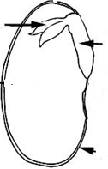**Label the following parts**

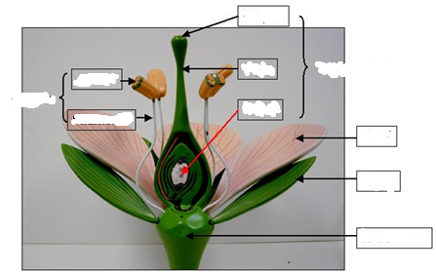

**This flower is literally named "Naked Hanging Men"**

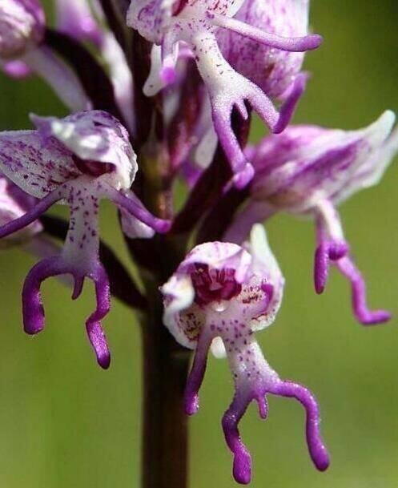

**Exam Questions**



1. [2010 OL] [2007 OL] [2006 OL]

The diagram shows a flower.

Examine the diagram and answer the questions that follow.

1. Identify the part of the plant labelled A and B in the diagram of the flower.
2. What is the function of the part labelled B?
3. Give one reason why insects are attracted to flowers.
4. [2010]

****The female part of the flower is called the carpel and the male part is called the stamen. The diagram is a cross section through a flower.

1. Name part A of the carpel and give its role in the sexual reproduction of plants.
2. Name part B of the stamen and give its role in the sexual reproduction of plants.
3. Give a way in which the pollen from the flower of one plant can be transferred to the flower of another plant.
4. Name the cell that is formed when a male gamete (sperm) and a female gamete (egg) combine.
5. What does the cell formed by the fusion of the male and female gametes of a flowering plant grow and develop into?
6. [2012]

An insect feeds on a flower and picks up pollen.

When the insect visits another flower of the same species it leaves some of the original pollen behind.

1. Give a second way in which transfer of pollen between plants occurs.
2. Draw a labelled diagram of a suitable flower showing the stigma, style, ovary, anther and filament.
3. Name the part of the flower that produces the male gamete.
4. Name the part of the plant that produces the female gamete.
5. What follows fertilisation in the flowering plants?

**Seed Dispersal**

1. ****[2011]

The diagram is of a section through a seed showing its structure.

Name the parts labelled A and B in the diagram.

1. [2006 OL]

Plants produce a wide variety of seed types which need to be dispersed (scattered) in order to avoid competition.

* 1. Identify how the seeds A and B in the diagram are dispersed.
  2. Name one resource that seeds must compete for with the parent plant.



1. [2008 OL] [2011 OL]

Seeds are dispersed in different ways.

1. Which off the seeds in the diagram is dispersed by wind?
2. Which off the seeds in the diagram is dispersed by animals?



1. [2009]

The child in the photograph is helping a dandelion to disperse its seeds.

1. Why is seed dispersion important for plants?
2. Give a second way, excluding wind, by which plants disperse seeds.

**Germination**

1. [2007][2010 OL]

List three conditions necessary for seeds to germinate.

1. [2011 OL][2006 OL]

A number of cress seeds were set up as shown in the diagram and left for a few days to investigate the conditions necessary for germination.

Test tubes A, B and D were kept in the laboratory at room temperature.

Test tube C was placed in the fridge at 4 °C.

The seeds in test tube B germinated after 3 days.

1. Why did the seeds in test tube A fail to germinate?
2. Why did the seeds in test tube C fail to germinate?
3. Why do only the seeds in test tubes B germinate?
4. Why is the water in test tube D boiled and cooled before use?
5. Why is this investigation considered to be a “fair test”?
6. Give two of the three conditions necessary for seeds to germinate.
7. [2007 OL]

A number of cress seeds were set up as shown in the diagram and left for a few days at a suitable temperature to investigate one of the conditions necessary for germination.

The seeds in test tube B germinated.

Study the diagram and answer the questions below using the table.

1. What condition is present in B but not present in A which allowed the seeds in B to germinate?
2. At which temperature, 1 °C or 15 °C, would the seeds be most likely to germinate?
3. [2007]

Describe using labelled diagrams an investigation to show that any two of the conditions that you have given are required for seeds to germinate. The investigation must have a suitable control.

1. [2009][2012]
2. Name a plant that can reproduce asexually.
3. Describe the way the plant that you have named reproduces asexually.

**Exam Solutions**

1. Stamen
2. Petal
3. Attract insects
4. Ovary; Contains ovules/ egg(s)/ female gamete(s)/ embryo(s)/ seed(s)
5. Anther; Produces pollen/ male gametes/ sperm
6. Insects/ wind/ water
7. Zygote
8. Embryo/ seed/ plant
9. Wind/ water/ artificial e.g. using a brush…
10. See diagram
11. Anther (do not accept (‘stamen’)
12. Ovule (accept ‘ovary’, do not accept ‘carpel’)
13. Zygote/ seed formation (dispersal)/ fruit formation
14. A: testa/ seed coat. B: food supply
15. A: Wind, B: Self / explode
16. Space / water / light / minerals
17. 1. W: Dandelion
    2. A: Strawberry
18. Colonise new places/ reduce competition (overcrowding)/ increase survival
19. Animal, self, water
20. Water, oxygen (air) and heat
21. No water
22. Too cold, no warmth
23. All the conditions necessary for germination are present
24. To remove oxygen
25. Only one thing changed at a time in each one
26. Moisture, oxygen, warmth, period of dormancy over
27. Water
28. 15°C 
29. A has water, air and heat

B has water and air but is kept in a refrigerator

C has air and heat but no water

D has water and heat but no air

(Note ‘cold’ alone gets no marks, refrigerate/ 40C is needed)

Result: Only seeds in A germinate

1. Buttercup/ grass/ raspberry / strawberry/ daffodil/ onion/ garlic/ potato/ spider plant...
2. Runners or rhizomes (buttercup/ grass/ raspberry / strawberry)/ bulbs or corms (onion/ garlic)/ tubers (potato)/ plantlets (spider plant)...

See the note on the final page for more on asexual reproduction.

**Plant Reproduction - Crossword**

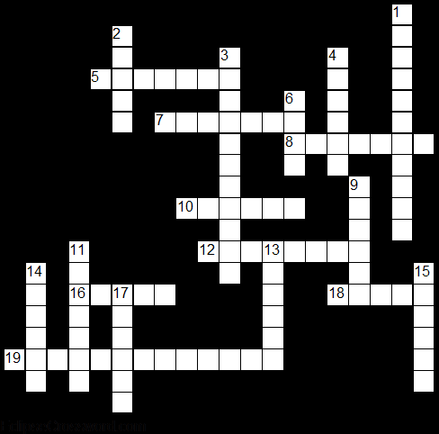

**Across**

5. This part of the seed grows downwards to from the root of the plant. (7)

7. This part of the seed grows upwards to form the shoot of the plant. (7)

8. Type of reproduction which involves the formation of new individuals from the cell(s) of a single parent. (7)

10. Used to attract insects into the flower; they may have guidelines on them and be scented. (6)

12. It is a condition necessary for germination. (8)

16. Protects the flower while it is in bud. (5)

18. This is the tough outer coating of the seed. (5)

19. It is the union of a nucleus of the pollen grain with the nucleus of the egg. (13)

**Down**

1. It is the transfer of pollen grains from an anther to a stigma. (11)

2. This produces the female gamete or egg. (5)

3. It is the resumption of growth after a period of dormancy. (11)

4. It is a condition necessary for germination. (6)

6. It is a condition necessary for germination. (4)

9. Sex cell. (6)

11. They can help with pollination. (7)

13. This is the male part of the flower. (6)

14. This produces pollen. (6)

15. This is the female part of the flower. (6)

17. This contains the sperm for fertilisation. (6)

**Plant Reproduction - Wordsearch**



**Find the following words in the grid above**

ANTHER, ASEXUAL, CARPEL,

FERTILISATION, GAMETE,

GERMINATION, HEAT, INSECTS,

MOISTURE, OVARY, OXYGEN,

PETALS, PLUMULE, POLLIN,

POLLINATION, RADICLE,

PUMULE, SEPAL, STAMEN, TESTA

Make sure that you understand the meaning of each word